Sample Employee Referral Bonus Policy
At [company], we strive to find and hire the best talent, people who demonstrate our values and who [company recruiting slogan]. We believe that our existing employees, who already meet these criteria, are in a great position to help us find the best talent. We recognize that current employees are likely to refer only those individuals best suited and qualified to work at our company, and therefore we wish to reward them for their referral efforts.
Incentives
We provide the following incentives to reward our current employees for providing referrals:
- $2000 dollars (before taxes) for any full-time, bi-weekly, exempt, and non-exempt professional positions across [company] @ 6 months of the date the referral was hired.
- $1500 dollars (before taxes) for any hourly, weekly manufacturing and production positions across [company] @ 6 months of the date the referral was hired.
Who can be referred?
- External candidates that are not currently employed by [company].
- Any employee that has left [company] voluntarily, and has been absent for at least 6 months.
Exceptions:
- Director level and above employees are ineligible for the employee referral bonus program.
- Employees in the HR function are ineligible for the employee referral bonus program.
- Employees involved in a particular hiring process for a position are ineligible for the employee referral bonus program.
- If a talent is working with [company], as a contractor, the contracted agency and Director of Talent Acquisition must give documented clearance and approval prior to the referral being submitted to ERIN.
Requirements
- You must be employed by [company] at the 6-month date, from which the referral was hired, to receive the incentive payout.
- The referred candidate, who is hired, must remain in active status at 6 months of the date of hire.
- The referred candidate must be in good standing, with documented verification from the supporting location’s HR Business Partner, at 6 months after the date of hire.
- Referrals must be submitted through the ERIN App.
Considerations:
- The recruitment process will work independently and no follow-up or influencing for candidates referred under employee referral program would be entertained.
- Participation is strictly voluntary and that employees should not be spending a significant amount of time away from their regular work activities engaging in recruitment.
- Referral submissions received after the candidate is interviewed or joins will not be entertained.
- Employees will not be eligible for bonus if the resume of the candidate is received from any other source other than through the referral submission process (i.e., through newspaper advertisements, separately through the internet, search firms, etc.)
- If the same resume has been received from two sources, the person/place from where it was received first would be treated as the “source” of the resume and treated accordingly. Referrals are tied to a specific position vs. the referral being considered a “blanket” referral for multiple positions.

BONUSES in ERIN
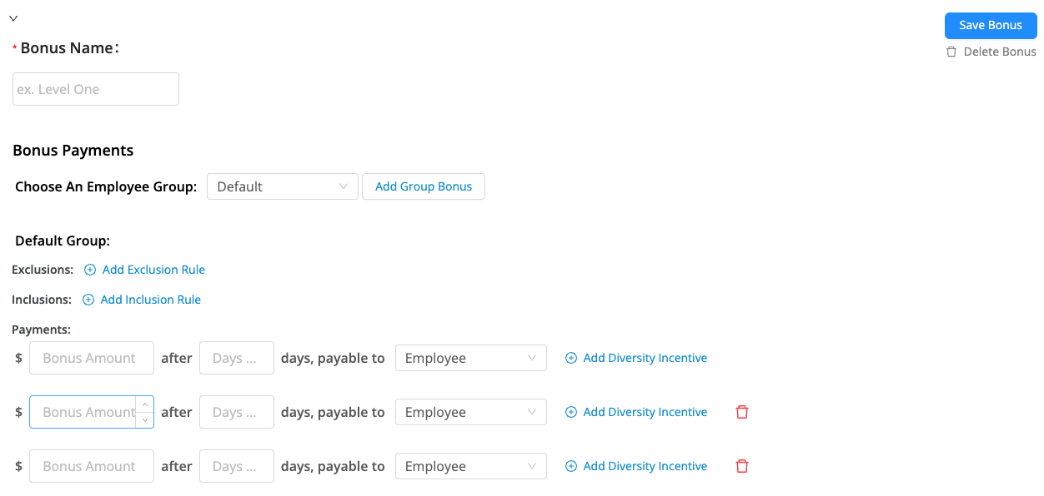

EXCLUSION RULES
